**HOW TO REMOVE BLANK ROWS FROM A DATASET USING EXCEL.**

One of the most common issues that arise when working with data is blank rows. These empty rows can disrupt your analysis and make your data hard to understand. But before removing them, we have to identify them.

In this article, we will go over the step-to-step process of how to identify and remove blank rows.

IDENTIFYING BLANK ROWS USING THE SPECIAL FEATURE.

1. On the Home tab, click on Find and Select option.
2. On the drop-down menu, click on ‘Go-to-Special’.

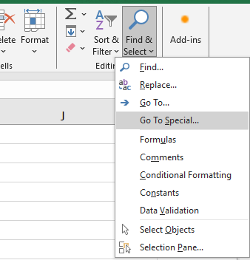

1. In the dialogue box, select ‘blanks’ and click ‘ok’.

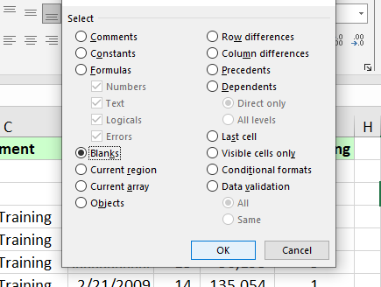

**REMOVING DUPLICATES USING ‘GO TO SPECIAL’**

1. Select the entire sheet.
2. Click the ‘Find and Select’ option on the home tab.
3. Select ‘Go to Special’, click blanks and ok.
4. Right click on any of the highlighted cells and click delete.
5. Check the ‘entire row’ option and click ok.

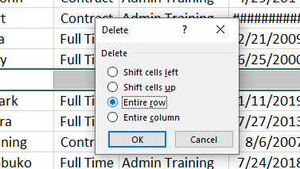

**FORMULA METHOD**

1. Add a new column to your sheet and label it ‘blank’.
2. In the first cell of the blank column, enter this formula ‘=IF(A2=””,0,1)’ click enter.

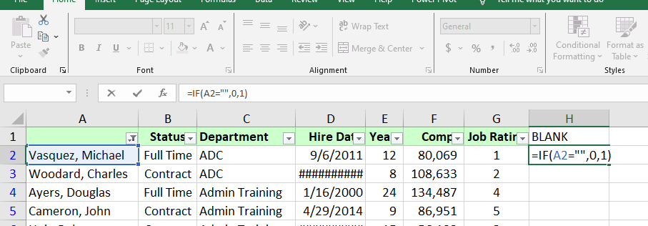

1. Autofill the entire column, by double clicking on the small box.

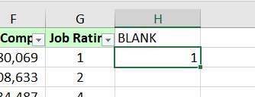

1. Filter out the rows with ‘0’ value in the blank column.

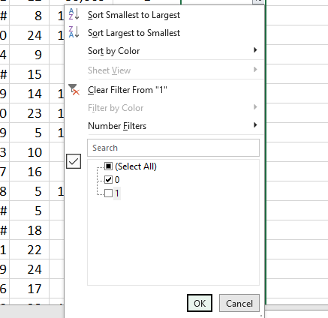

1. Select the filtered data and delete the rows.

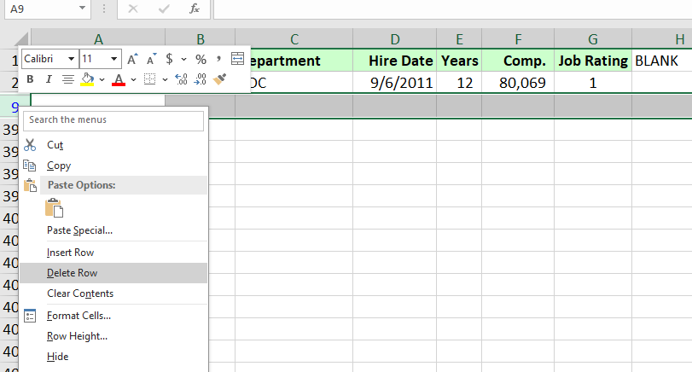

P.S: Is best to save a copy of your original data before making changes, so you can easily refer back when needed.